
UNIVERSITY OF BOLTON
BSC COMPUTING
COURSEWORK SUBMISSION FORM

Student/Centre to complete:

SURNAME/FAMILY NAME: SABIR FORENAMES: NAVEED

BOLTON STUDENT ID: 2224755 EMAIL: ns7crt@bolton.ac.uk

DATE OF SUBMISSION: 27 October 2023 @ 16:00

MODULE NO./TITLE:…SWE5202 Data Structures and Algorithms…………………………

TUTOR’S NAME: Abdul Razak…………………...... ……………………

COURSEWORK TITLE: Portfolio item 1: Cloning, Sorting, Searching, shallow and deep copying of objects. Please state if this is your FIRST submission OR REFERRED/DEFERRED submission OR a REPEAT submission?
FIRST

…………………..…………………………………………………………………………………………
Declaration
I hereby declare that this work is my own work. I understand that if I am suspected of plagiarism or another form of cheating, my work be referred to Academic Registrar and/or the Board of Examiners, which may result in me being expelled from the programme. I understand once I submit this work, it will automatically belong to the University of Bolton.

Creative Technologies

Course / Programme: BEng (Hons) in Software Engineering

Module name and code: Data Structures and Algorithms
SWE5202

Tutor: Abdul Razak

Assessment Number: One

Assessment Title: Cloning, Sorting, Searching, shallow and deep copying of objects.

Weighting 25%

Issue Date: W/C 09 October 2023

Submission Deadline: 27 October 2023 @16.00.

Figure 1 3
Figure 2 4
Figure 3 4
Figure 4 4
Figure 6 6
Figure 7 6

Contents
Q1. Do you have a problem with sorting the array if the array dimension is declared greater than the number of appointments? Why might this be? 5
Arrays.sort(appointmentArray, 0, count) EXPLAINED. 6
Q2. Does the search look for the same object references or the same attribute values? 7
Q3. What exactly does the search try to match up? Can you verify your answer? 8
Q4. Does this test still work if the Comparable interface is removed? 10
Q5. Would you say that the Comparator class is a better option for this stage 3 than the Comparable interface? If so, why? 11
Q6. Does the search based on natural ordering still work? If not, why not? What does work? 12
General overview of topics 13
UML 15
REFERENCES 16

Q1. Do you have a problem with sorting the array if the array dimension is declared greater than the number of appointments? Why might this be?

Java allows the program to create an array with a dimension greater than the number of elements initially placed in the array. In that case the additional array elements will be initialised to their default values which is NULL in object arrays. (Bloch, 2018)

Code below.
Figure 1

If the Appointment objects in appointmentList are less than the size of the array, the additional elements in appointmentList will be initialised to NULL. However, this will NOT affect the sorting process because the Array.sort method will only consider the non-NULL elements in the array and sort them accordingly. (CAY S. HORSTMANN, 2016)

So, there should be no problem sorting the array even if the array dimension is declared greater than the number of appointments. The sorting operation will work correctly based on the non-null elements within the array. (Eckel, 2006)

Arrays.sort(appointmentArray, 0, count) EXPLAINED.

// Sort the array of appointments from index 0 to count
Arrays.sort(appointmentArray, 0, count);

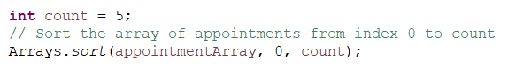
Figure 2

The code above sorts the only segment of the array that contains the first count elements. Aside from that, all the components are unsorted. That is, if you execute a binary search for searchAppointment and searchAppointmentClone, the search will be performed inside the array's sorted half, and the results will differ.

The result changes depending on the count value and the order of the array members. If the count is set to a number smaller than the array's entire length, the first few entries will be sorted and considered in the binary search. The remaining components would not be included in the search.

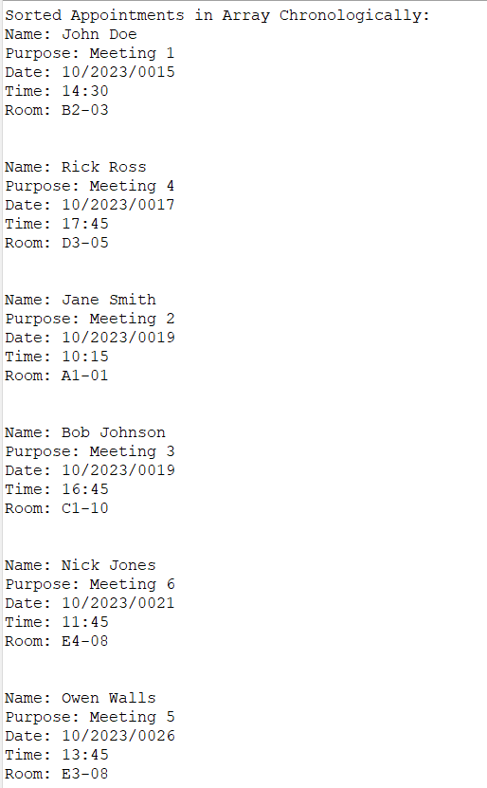
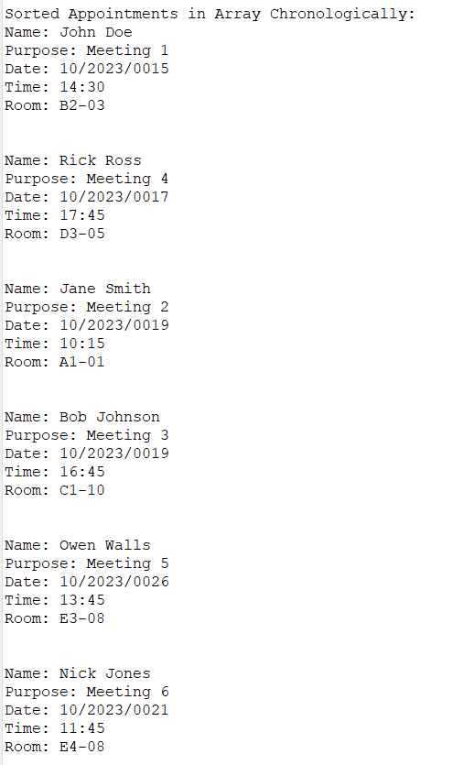
The binary search results for searchAppointment and searchAppointmentClone will be based on the sorted component of the array and may or may not differ from the prior version of the code. The difference in results will be determined by the order of sorting and if the elements being searched for are inside the sorted range.

Figure 4
Figure 3
The output on the left has all the Appointments sorted chronologically but the one on the right only sorts the first 3.

Q2. Does the search look for the same object references or the same attribute values?

The search for the appointments using binary search is based on comparing the same attribute values rather than the same object references. The search is conducted by comparing the attributes of the objects for equality, not the memory references of the objects. (Joyce Farrell, 2015)

Specifically, the search conducted in the code, searches for searchAppointment and searchAppointmentClone based on their attributes. The compareTo method within the Appointment class defines the logic for comparing the attributes of two Appointment objects. The binary search relies on this comparison to determine the position of the searched appointment in the sorted list. (Herbert Schildt, 2014)

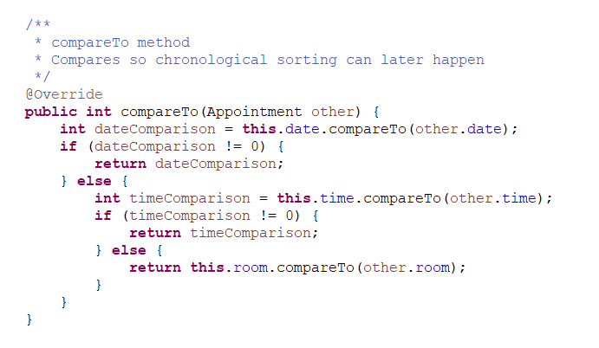
Figure 5

The compareTo function compares the date, time, and room properties of Appointment objects to achieve chronological sorting. It doesn't try to compare object references. This means that if an Appointment object exists in the sorted list with identical attribute values, the binary search will discover it, even if the object reference is different.

Q3. What exactly does the search try to match up? Can you verify your answer?

The search is attempting to match the searchAppointment and searchAppointmentClone objects with their chronological order among the sorted list of appointments. The search is based on the attributes of these objects (name, purpose, date, time, and room) rather than matching the objects’ memory references.
Code Breakdown
- The appointmentList is created and filled with Appointment objects, which are then sorted using the Collections.sort method.

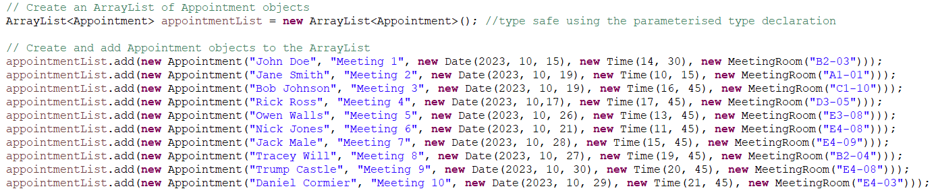
appointmentList created and filled.
Figure 5

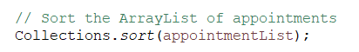
appointmentList sorted.
Figure 6

Sorting is done based on the chronological order of appointments, determined by the compareTo method in the Appointment class, which compares the attributes of Appointment objects (date, time, and room).

- appointmentArray is an array of Appointment objects that is created to reflect the same.
data and order as appointmentList.
Figure 7

- searchAppointment is an unsorted Appointment object that is created with attributes matching one of the appointments in the list.
Figure 8

- A clone of searchAppointment named searchAppointmentClone is also created.

Figure 9
- The code uses binary search methods (Collections.binarySearch and Arrays.binarySearch) to search for searchAppointment and searchAppointmentClone within the sorted appointmentList and appointmentArray.

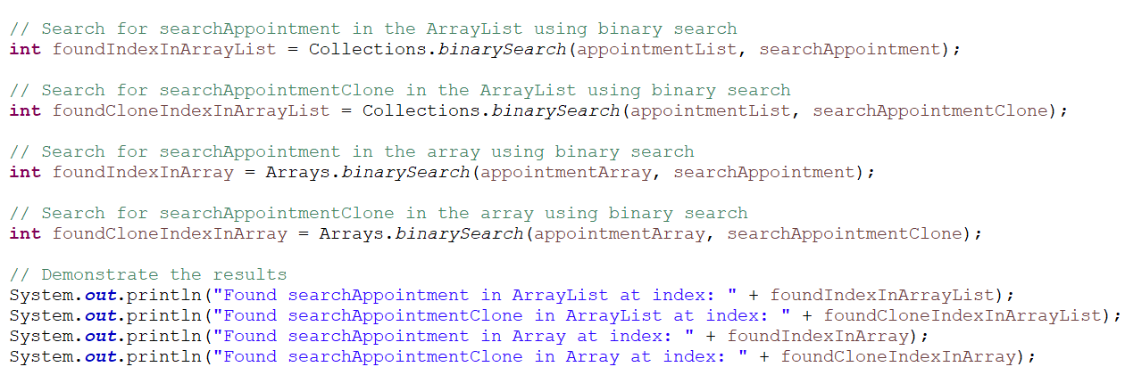
Figure 10

- Output results

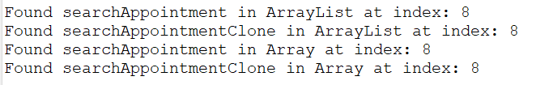
Figure 11

The important thing to note here is that the search methods compare the attribute values of searchAppointment and searchAppointment-Clone (name, purpose, date, time, and room) with the properties of the appointments in the sorted list. It is not concerned with the memory references of these objects, but with how their attribute values compare to those in the sorted list. The code's ability to search for and identify matched appointments based on attribute values supports this.

Q4. Does this test still work if the Comparable interface is removed?

If the comparable interface from the Appointment class is removed, and an external comparator is not provided, the test would not work as it should. The reason is that both Collection.sort and Arrays.sort rely on the natural ordering provided by the Comparable interface when comparing elements. When Collection.sort(appointmentList) and Arrays.sort(appointmentArray), these methods expect the elements in the list or array to implement the Comparable interface to determine their natural order. (Maurice Naftalin and Philip Wadler, 2007)

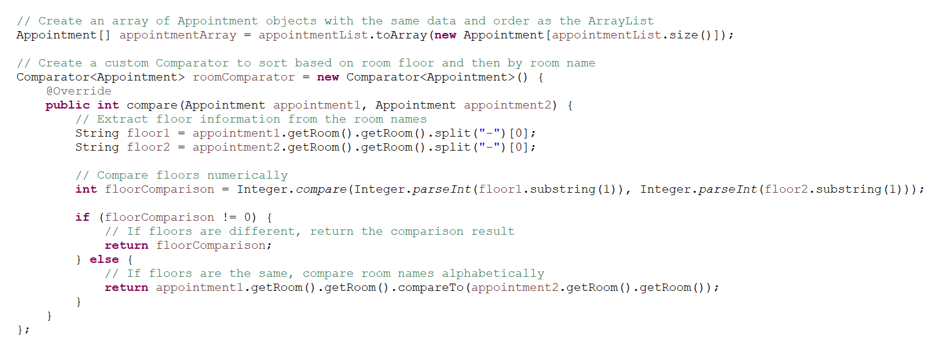
Figure 12

Since the Appointment class initially implements the Comparable interface, Collection.sort and Array.sort are usable for sorting appointments based on their natural order, as defined by compareTo method in the Appointment class.

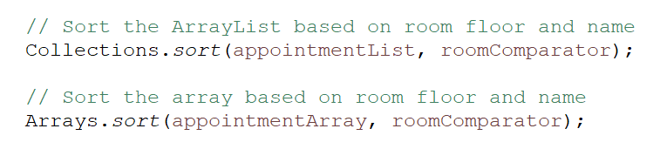
Figure 13

However, if the Comparable interface from the Appointment class is removed and a custom Comparator is not provided when calling Collection.sort and Arrays.sort, compilations errors will occur because the sorting methods will NOT know how to compare Appointment objects without providing the natural order by the compareTo method. (Michael T. Goodrich, Roberto Tamassia and Michael H. Goldwasser, 2014)

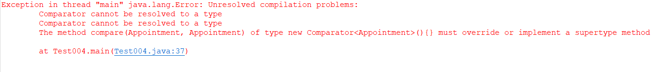
Figure 14

Q5. Would you say that the Comparator class is a better option for this stage 3 than the Comparable interface? If so, why?

In the context of stage 3 of the code, using the Comparator class rather than the Comparable interface for sorting is preferred. This choice meets the requirements of the stage as well as the code's specific sorting criteria.

Advantages the Comparator class offers:

- On a case-by-case basis Sorting Rules That Are Unique: The Comparator class may be used to produce case-by-case custom sorting criteria. This code's objective is to arrange Appointment objects alphabetically by room name, then by meeting room floor. This is a specialised sorting criterion for Appointment items that may or may not be relevant in the natural order. You can use a Comparator to set and adjust sorting criteria without having to edit the Appointment class itself.
- External Sorting Logic: Using a Comparator removes the need to modify the Appointment class to implement Comparable. This keeps the Appointment class neat and focused on its key functions, which is especially important when the natural ordering of the class should not always be followed.
- Numerous Sorting Options: Comparator supports several sorting options for the same class without generating conflicts. Different Comparator instances can be used to rank Appointment objects in various ways, providing flexibility to sorting algorithms.
- Improved Code Maintenance: Comparator allows for more separation of concerns in your code. It splits the sorting logic into a separate class, making the code easier to manage and comprehend. Furthermore, it follows the Single Responsibility Principle in programme design. (Comparator (Java Platform SE 8 ). 2023)

Therefore, utilising a Comparator is a superior solution in this scenario because the sorting criteria are particular to this stage and do not need to be the natural order for all Appointment objects, because it allows more flexibility, maintainability, and adherence to the code's specific needs.

Q6. Does the search based on natural ordering still work? If not, why not? What does work?

Natural ordering search does not function properly. The natural ordering of Appointment objects is determined by the Comparable interface. The Appointment class has been modified to include a comparator(roomComparator) to rank objects that deviate from the standard ordering based on specified parameters (room floor and room name).

The compareTo function of the Appointment class, which is used for sorting, is typically utilised for natural ordering. When a custom Comparator is specified during sorting, the natural ordering defined by the compareTo method is overridden.

The custom roomComparator is used for item ordering and binary search operations. Therefore, searching for searchAppointment with natural ordering produces incorrect results since the objects in the list are organised differently.

In the code, the search is based on the custom sorting criteria specified in the roomComparator. This Comparator arranges Appointment objects based on room floor and room name, and it performs binary search operations on Appointment objects. Based on these specified parameters, Comparator finds the items in the list.

To conclude, because the items are sorted using a custom Comparator, the natural ordering search does not work as intended. For this code, the binary search based on the custom roomComparator is the correct way. (Brian Goetz, Tim Peierls and David Holmes, )

UML

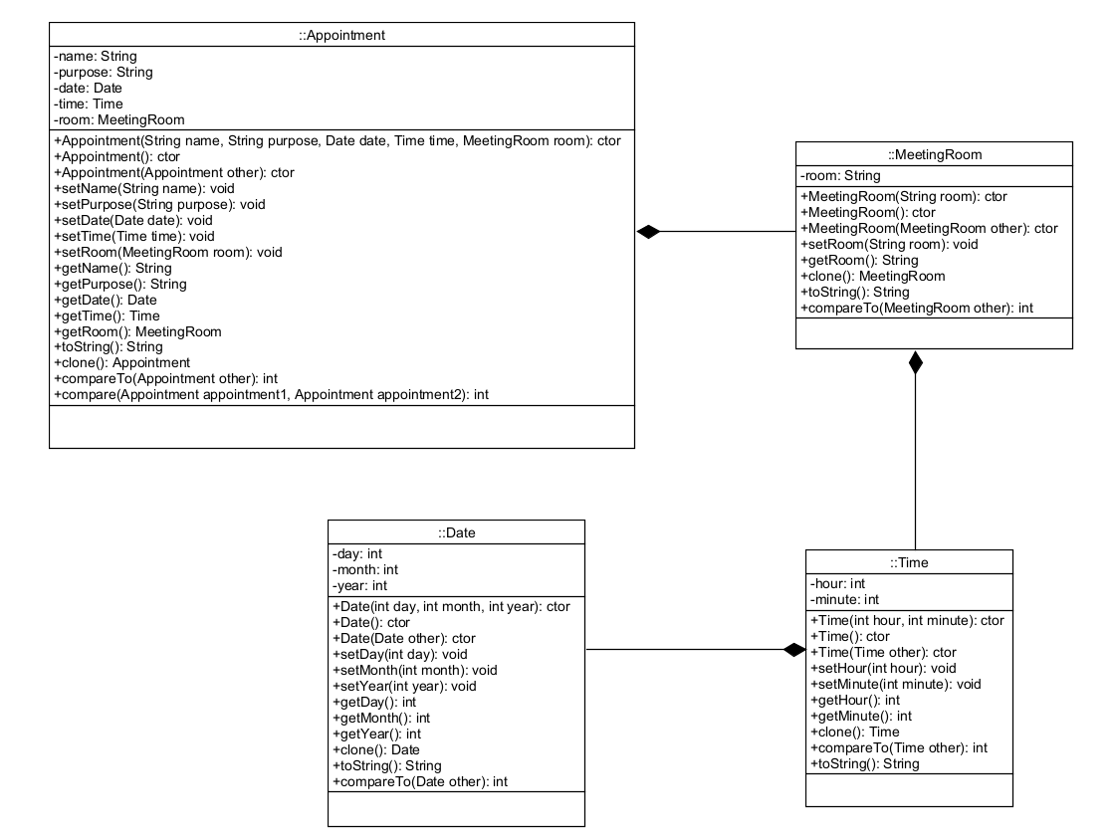
Figure 15

Learning outcomes / Topics explained

Sorting and searching algorithms for linear data structures.

It is a fundamental task in computer science and data processing to implement sorting and searching algorithms for linear data structures. Linear data structures, such as arrays, linked lists, and stacks, are collections of sequentially ordered data components. Sorting and searching are necessary actions for storing and retrieving data inside these systems. This procedure entails precisely arranging components and scanning the linear data structure for a given item. (DONALD E. KNUTH, 2014)

Sorting algorithms reorder the components of a linear data structure, such as ascending or descending.

The following are some examples of common sorting algorithms:

- Bubble Sort verifies adjacent items iteratively, exchanging them if they are out of order, until the entire structure is sorted.

- Quick Sort partitions the data and recursively sorts sub-arrays using a divide-and-conquer approach.

- Merge Sort breaks data down into smaller parts, sorts them, and then merges them to create a sorted structure.

Algorithms for Searching: To identify a specific element inside a linear data structure, searching algorithms are utilised.

The following are examples of typical search algorithms:

- Linear Search goes through each element one by one until the target element is located or the data structure is finished.

- Binary Search is a search strategy that operates on sorted data structures by regularly splitting the search space in half, hence decreasing the search space.

- Hashing, in some circumstances, employs a hash function to map keys to precise places in a data structure, allowing for constant-time retrieval.

When implementing these algorithms, several aspects must be addressed, including the size of the data structure, data distribution, and the application's special needs. The algorithm used can have a considerable influence on the operation's efficiency and performance.

It is critical to recognise that these algorithms have been thoroughly explored, analysed, and modified throughout time. As a result, finding the best sorting or searching algorithm for a particular assignment is critical to achieving the intended results. New algorithms and optimisations occur as technology improves, boosting the efficiency and speed of sorting and searching operations in linear data structures. (Thomas H. Cormen et al., 2022)

Shallow, deep copying & Comparable and Comparator interfaces.

Shallow and Deep Copying:
Shallow and deep copying are methodologies used in object-oriented programming to reproduce objects, each with its own memory allocation, to ensure data integrity and avoid undesirable side effects when working with many references to the same object.

Shallow Copy:
Shallow copying generates a new object without reproducing the prior object's elements. Rather, it repeats references to the items included inside. As a result, changes to the objects of the cloned object influence the original object, and vice versa. Because it does not repeat the complete object hierarchy, this strategy uses less memory. However, if not properly handled, it might lead to unanticipated conduct. (GeeksforGeeks, (n.d.)).

Deep Copy:
Deep copying recursively makes a totally independent clone of the original item and all the objects it includes. Changes to the cloned item have no effect on the original, and vice versa.
Deep copying divides data, allowing each component to function independently. It consumes more memory since it repeats the whole object hierarchy.( Joshi, P., & Heda, S. (2013)).

Comparable and Comparator Interfaces:
The Comparable and Comparator interfaces are used to offer customised object ordering and sorting behaviour, allowing objects to be compared and sorted depending on specified criteria.

Comparable Interface:
The Java standard library includes the Comparable interface. Classes that implement this interface provide their instances with a natural ordering. It only has one method, compareTo, that describes how to compare and sort two objects of the same type. The term comparable refers to items that have an intrinsic ordering, such as integers or strings.

Comparator Interface:
The Java standard library also includes the Comparator interface. It allows for the creation of diverse ways for comparing and organising things. A Comparator class provides distinct comparison criteria that are distinct from the inherent ordering of objects. Comparators can in handy when you need to rearrange elements without changing the items themselves. (Oracle Corporation, n.d.)

REFERENCES

3 Methods Common to All Objects. ( ) ed. [Online] : . Available from: https://learning.oreilly.com/library/view/effective-java-3rd/9780134686097/ch3.xhtml.
[Accessed].

Eckel, B. (2006). Thinking in Java Fourth Edition. [online] Available at: https://sd.blackball.lv/library/Thinking_in_Java_4th_edition.pdf.
CAY S. HORSTMANN (2016) CORE JAVA. , [Online] ( ), pp. Available from: https://d1b10bmlvqabco.cloudfront.net/attach/jc58lmmawh926u/jc5b5p5oen65ss/jc80gkzos6l4/corejavavolumeifundamentals.pdf. [Accessed].
Herbert Schildt (2014) Java The complete Reference. ed. [Online] : McGraw-Hill Education. Available from: http://www.sietk.org/downloads/javabook.pdf. [Accessed].
Joyce Farrell (2015) Java Programming. , [Online] ( ), pp. Available from: https://sd.blackball.lv/library/Java_Programming_8th_Edition_(2015).pdf. [Accessed].
Maurice Naftalin and Philip Wadler (2007) Java Generics and Collections. , [Online] (October 2006), pp. 285 Available from: http://www.r-5.org/files/books/computers/languages/java/main/Maurice_Naftalin_and_Philip_Wadler-Java_Generics_and_Collections-EN.pdf. [Accessed].
Michael T. Goodrich, Roberto Tamassia and Michael H. Goldwasser (2014) Data Structures and
Algorithms in Java™. , [Online] ( ), pp. 738 Available from: http://bedford-computing.co.uk/learning/wp-content/uploads/2016/08/Data-Structures-and-Algorithms-in-Java-6th-Edition.pdf. [Accessed].
Brian Goetz, Tim Peierls and David Holmes ( ) Java Concurrency in Practice - Authors. , [Online] ( ), pp. Available from: https://jcip.net/authors.html. [Accessed].
Comparator (Java Platform SE 8 ). (2023) [Online] Available from: https://docs.oracle.com/javase/8/docs/api/java/util/Comparator.html. [Accessed].
Thomas H. Cormen, Charles E. Leiserson, Ronald L. Rivest and Clifford Stein (2022) Introduction to Algorithms. Fourth Edition ed. [Online] : . Available from: https://dl.ebooksworld.ir/books/Introduction.to.Algorithms.4th.Leiserson.Stein.Rivest.Cormen.MIT.Press.9780262046305.EBooksWorld.ir.pdf. [Accessed].
DONALD E. KNUTH (2014) THE ART OF
COMPUTER PROGRAMMING. , [Online] Volume 3 / Sorting and Searching ( ), pp. 803 Available from: https://www.haio.ir/app/uploads/2022/01/The-Art-of-Computer-Programming-Volume-3-Sorting-and-Searching-by-Donald-E.-Knuth-z-lib.org_.pdf. [Accessed].
Joshi, P., & Heda, S. (2013). "Comparative Analysis of Shallow and Deep Copy." International Journal of Emerging Technology and Advanced Engineering, 3(5), 719-724
Oracle Corporation. (n.d.). "Comparable." Java™ Platform, Standard Edition 8 API Specification. https://docs.oracle.com/javase/8/docs/api/java/lang/Comparable.html
GeeksforGeeks. (n.d.). "Shallow Copy and Deep Copy in Java." https://www.geeksforgeeks.org/shallow-copy-and-deep-copy-in-java/

In this assessment I have achieved the following objectives
Tick appropriate box  NA – not attempted : Part – part completed : Full – fully completed | NA | Part | Full
Stage 1 |  |  | x
Stage 2 |  |  | x
Stage 3 |  |  | x
Stage 4 |  |  | x

Learning Outcomes:

LO1: Implement sorting and searching algorithms for linear data structures.

LO2: Implement shallow and deep copying and use the Comparable and Comparator interfaces.

